Numerical Methods to PDEs

Homework#3

Chen Zhang

**Problem 1**

*Some explanation and formulation of the steps:*

Step 2:

The Jacobian can be written and formulated as:

Jacobian =  , After exploring on the shape functions and coordinates, we have:

Jacobian = 

Step 3:

The gradient of the basis function on the reference triangle can be formulated as:

, We have the relation: 

Step 4:

The gradient of the basis function on the element triangle can be formulated as:

 ( Since the Jacobian I’m using is the transpose of what we talked

about in class, therefore there is no transpose here )

Step 5:

Aelem can be calculated easily with the formulation above . Also , the integration

 is trivial since is constant value in the three cases ( In case 3 we only need to determine if the element lies in the center circle ).

Step 6:

The integration  is simply  since is constant value (Only that in case 2 and 3 we need to determine the location of the element). It is easy to calculate that .

*The Results are plotted as below:*

Case a):

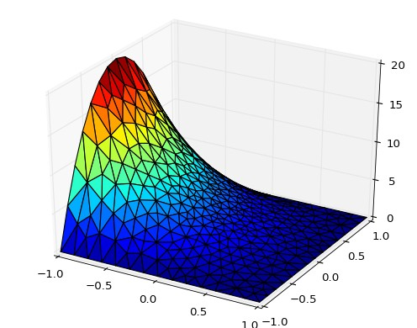

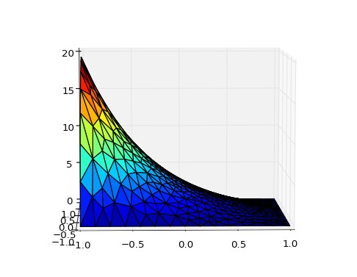

Case b):

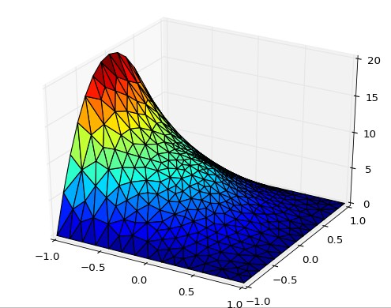

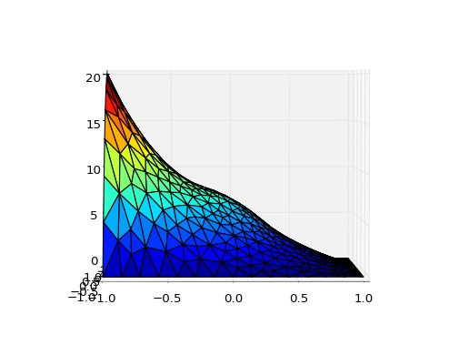

Case C):

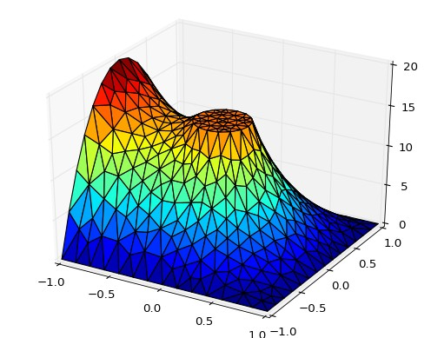

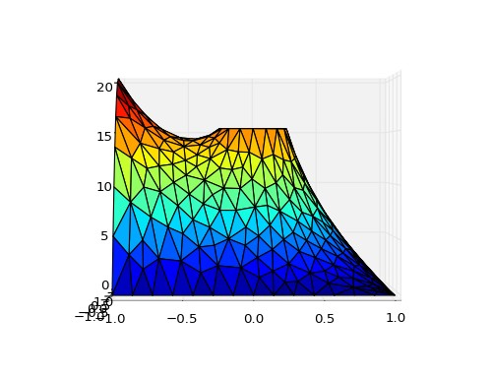

**Problem 2**

*Some explanation and formulation of the steps:*

Please refer to the code

*The Results are plotted as below:*

Case a):

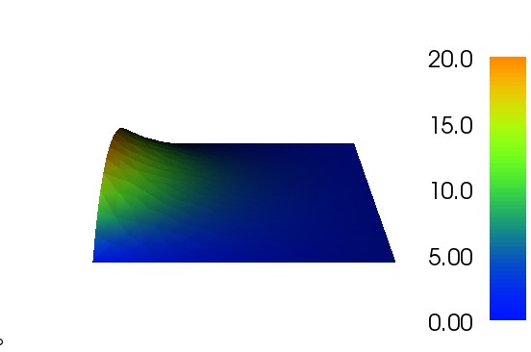

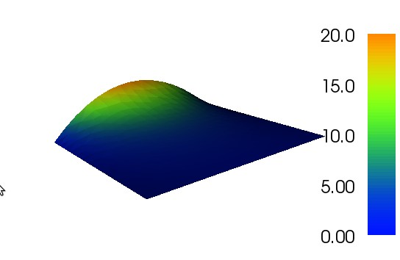

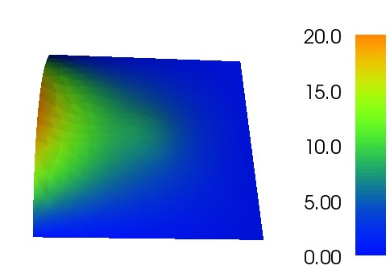Case b):

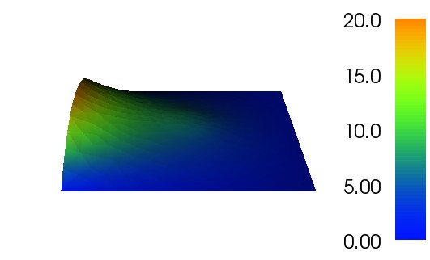

Case c):

